**REPORT OF FOUR WEEKS TRAINING**

**(Python Training)**

***Submitted in partial fulfilment of the***

***requirements for the award of the degree***

***of***

**BACHELOR OF TECHNOLOGY**

**IN**

**DEPARTMENT OF COMPUTER SCIENCE AND ENGINEERING (Artificial Intelligence & Machine Learning)**



***Submitted by:***

***SOURABH KUMAR (Roll No.: 2019374)***



ਆਈ. ਕੇ. ਗੁਜਰਾਲ ਪੰਜਾਬ ਟੈਕਨੀਕਲ ਯੂਨੀਵਰਸਿਟੀ, ਜਲੰਧਰ

I.K. GUJRAL PUNJAB TECHNICAL UNIVERSITY, JALANDHAR

**TABLE OF CONTENTS**

|  |  |  |
| --- | --- | --- |
| **Chapter** | **Description** | **Page No.** |
| 1 | **CHAPTER 1** | 9 |
| 1.1 | INTRODUCTION | 9 |
| 1.2 | BACKGROUND | 10 |
| 1.3 | THEORETICAL EXPLANATION | 12 |
| 1.4 | SOFTWARE & HARDWARE USED | 13 |
| 2 | **TRAINING WORK UNDERTAKEN** | 14 |
| 2.1 | SEQUENTIAL LEARNING STEPS | 14 |
| 2.2 | METHODOLOGY | 16 |
| 2.3 | PROJECT UNDERTAKING | 16 |
| 2.4 | How it’s Made | 18 |
| 3 | **RESULTS AND DISCUSSION** | 20 |
| 4 | **CONCLUSION** | 28 |

|  |  |
| --- | --- |
| **Topics** | **Page No.** |
| Certificate by Company | 4 |
| Candidate’s Declaration | 5 |
| Abstract | 6 |
| Acknowledgement | 7 |
| About the Company | 8 |

**TABLE OF FIGURES**

|  |  |  |
| --- | --- | --- |
| **Figure** | **Description** | **Page No.** |
| 1 | Home Page of App | 20 |
| 2 | Display Page of App | 21 |
| 3 | Add Book Page of App | 21 |
| 4 | Lend Book page of App | 22 |
| 5 | Warning Message If Wrong Book Name Entered | 23 |
| 6 | User Entered The Book Name | 24 |
| 7 | Book Name Entered Which is Present in Available Book List | 24 |
| 8 | User Entered Book Name Which is Already Lended By Another User | 25 |
| 9 | Return Book Button | 26 |
| 10 | User Entered The Book Name That is Not Lended Yet | 26 |
| 11 | User Entered Book Name Which is Present in Lended Book List | 27 |

**CERTIFICATE BY COMPANY**

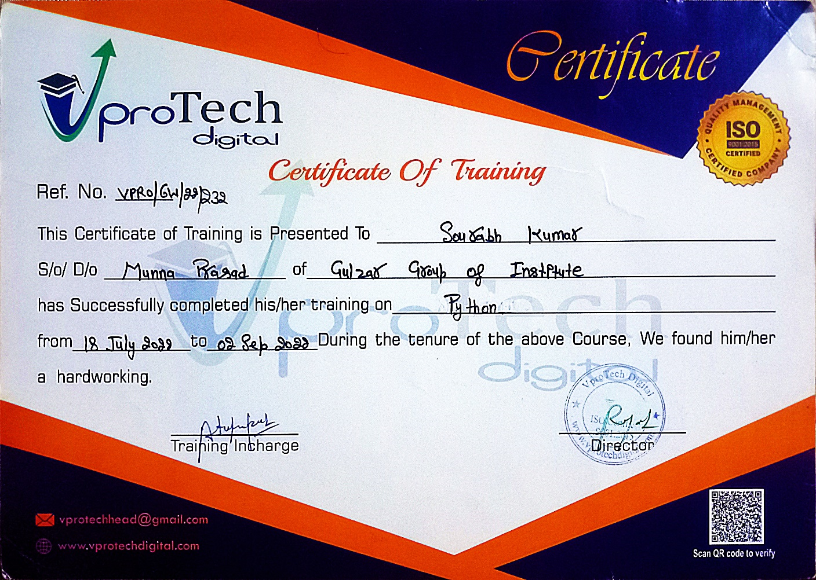

**CANDIDATE'S DECLARATION**

___________________________________________________________________________

### I, **SOURABH KUMAR**, hereby declare that I have undertaken four week training at **VproTech Digital** during a period from 18th July, 2022 to 2nd Sept, 2022 in partial fulfilment of requirements for the award of degree of B.Tech. (Computer Science and Engineering (Artificial Intelligence & Machine Learning)) at Gulzar Group of Institutes, Khanna, Punjab. The work which is being presented in the training report submitted to Department of Computer Science and Engineering at Gulzar Group of Institutes, Khanna, Punjab is an authentic record of training work.

**Candidate Signature**

This is to certify that the above statement made by the candidate is correct to the best of my knowledge and belief.

**Signature of Internal Examiner Signature of External Examiner**

**ABSTRACT**

I have created a Library Management System in Python during my Six Weeks Industrial Training in a recognized company VPROTECH which is situated in Mohali, Chandigarh. With the Mentorship of supervisor Mrs. Prabhjot, it was possible to make this project within 1 week. I have picked this project i.e., Library Management System because it Forms the Basics of Python. Since the Management System is the base for all the Product Based as well as for the Service Based Company. I have learned Python for Making Apps Like This during my training and with that, I have built this project. And this project helps in developing my Programming skills.

**ACKNOWLEDGEMENT**

This training was a quite a learning experience for me at each and every step. It is my pleasure to acknowledge the contributions of all who have helped me and supported me during the completion of this Project report. First, I thank God for helping us in one way or another and providing strength and endurance to us.

I am also humbly obliged by the support of my friends for their love and caring attitude. The sentimental support they rendered to me is invaluable and everlasting. They have helped me through thick and thin and enabled me to complete the work with joy and vigor.

I am also thankful to my parents, elders, and all family members for their blessing, motivation, and inspiration throughout my work and for bearing with me even during stress and bad temper. They have always provided me with high moral support and contributed in all possible ways to the completion of this Capstone report.

**ABOUT THE COMPANY**

**VproTech** was created with a mission to create skilled software engineers for our country and the world. It aims to bridge the gap between the quality of skills demanded by industry and the quality of skills imparted by conventional institutes. With assessments, learning paths and courses authored by industry experts, DreamUny helps businesses and individuals benchmark expertise across roles, speed up release cycles and build reliable, secure products.

**CHAPTER 1**

**1.1 INTRODUCTION**

Python is a popular programming language. It was created by Guido van Rossum, and released in 1991.

It is used for:

* web development (server-side),
* software development,
* mathematics,
* system scripting.

### **1.1.1 Python Can Do: -**

* Python can be used on a server to create web applications.
* Python can be used alongside software to create workflows.
* Python can connect to database systems. It can also read and modify files.
* Python can be used to handle big data and perform complex mathematics.
* Python can be used for rapid prototyping, or for production-ready software development.

### **Why Python?**

* Python works on different platforms (Windows, Mac, Linux, Raspberry Pi, etc).
* Python has a simple syntax similar to the English language.
* Python has syntax that allows developers to write programs with fewer lines than some other programming languages.
* Python runs on an interpreter system, meaning that code can be executed as soon as it is written. This means that prototyping can be very quick.
* Python can be treated in a procedural way, an object-oriented way or a functional way.

**1.1.3 Good to know**

* The most recent major version of Python is Python 3, which we shall be using in this tutorial. However, Python 2, although not being updated with anything other than security updates, is still quite popular.
* In this tutorial Python will be written in a text editor. It is possible to write Python in an Integrated Development Environment, such as Thonny, Pycharm, Netbeans or Eclipse which are particularly useful when managing larger collections of Python files.

**1.1.4 Python Syntax compared to other programming languages**

* Python was designed for readability, and has some similarities to the English language with influence from mathematics.
* Python uses new lines to complete a command, as opposed to other programming languages which often use semicolons or parentheses.
* Python relies on indentation, using whitespace, to define scope; such as the scope of loops, functions and classes. Other programming languages often use curly-brackets for this purpose.

**1.2 BACKGROUND**

Python was conceived in the late 1980s by [Guido van Rossum](https://en.wikipedia.org/wiki/Guido_van_Rossum) at [Centrum Wiskunde & Informatica](https://en.wikipedia.org/wiki/Centrum_Wiskunde_%26_Informatica) (CWI) in the [Netherlands](https://en.wikipedia.org/wiki/Netherlands) as a successor to the [ABC programming language](https://en.wikipedia.org/wiki/ABC_(programming_language)), which was inspired by [SETL](https://en.wikipedia.org/wiki/SETL), capable of [exception handling](https://en.wikipedia.org/wiki/Exception_handling) (from the start plus new capabilities in Python 3.11) and interfacing with the [Amoeba](https://en.wikipedia.org/wiki/Amoeba_(operating_system)) operating system. Its implementation began in December 1989. Van Rossum shouldered sole responsibility for the project, as the lead developer, until 12 July 2018, when he announced his "permanent vacation" from his responsibilities as Python's "[benevolent dictator for life](https://en.wikipedia.org/wiki/Benevolent_dictator_for_life)", a title the Python community bestowed upon him to reflect his long-term commitment as the project's chief decision-maker. In January 2019, active Python core developers elected a five-member Steering Council to lead the project.Python 2.0 was released on 16 October 2000, with many major new features. Python 3.0, released on 3 December 2008, with many of its major features [backported](https://en.wikipedia.org/wiki/Backporting) to Python 2.6.x and 2.7.x. Releases of Python 3 include the 2 to 3 utility, which automates the translation of Python 2 code to Python 3. Python 2.7's [end-of-life](https://en.wikipedia.org/wiki/End-of-life_product) was initially set for 2015, then postponed to 2020 out of concern that a large body of existing code could not easily be forward-ported to Python 3. No further security patches or other improvements will be released for it. Currently only 3.7 and later are supported. In 2021, Python 3.9.2 and 3.8.8 were expedited as all versions of Python (including 2.7) had security issues leading to possible [remote code execution](https://en.wikipedia.org/wiki/Remote_code_execution) and [web cache poisoning](https://en.wikipedia.org/wiki/Cache_poisoning).

In 2022, Python 3.10.4 and 3.9.12 were expedited and 3.8.13, and 3.7.13, because of many security issues. When Python 3.9.13 was released in May 2022, it was announced that the 3.9 series (joining the older series 3.8 and 3.7) will only receive security fixes going forward. On September 7, 2022, four new releases were made due to a potential [denial-of-service attack](https://en.wikipedia.org/wiki/Denial-of-service_attack): 3.10.7, 3.9.14, 3.8.14, and 3.7.14.

As of November 2022, Python 3.11.0 is the current stable release and among the notable changes from 3.10 are that it is 10–60% faster and significantly improved error reporting.

**1.3 THEORETICAL EXPLANATION**

**1.3.1 Python** is an interpreted high-level general-purpose programming language. Its design philosophy emphasizes code readability with its use of significant indentation. Its language constructs as well as its object-oriented approach aim to help programmers write clear, logical code for small and large-scale projects.

Python is dynamically typed and garbage-collected. It supports multiple programming paradigms, including structured (particularly, procedural), object-oriented and functional programming. It is often described as a "batteries included" language due to its comprehensive standard library.

**1.3.2 Development**

Python's development is conducted largely through the Python Enhancement Proposal (PEP) process, the primary mechanism for proposing major new features, collecting community input on issues and documenting Python design decisions. Python coding style is covered in PEP 8. Outstanding PEPs are reviewed and commented on by the Python community and the steering council.

Enhancement of the language corresponds with the development of the CPython reference implementation. The mailing list python-dev is the primary forum for the language's development.

Development originally took place on a self-hosted source-code repository running Mercurial, until Python moved to GitHub in January 2017.

**1.3.3 Uses**

Python can serve as a scripting language for web applications, e.g., via mod_wsgi for the Apache webserver. With Web Server Gateway Interface, a standard API has evolved to facilitate these applications. Web frameworks like Django, Pylons, Pyramid, TurboGears, web2py, Tornado, Flask, Bottle and Zope support developers in the design and maintenance of complex applications. Pyjs and IronPython can be used to develop the client-side of Ajax-based applications. SQLAlchemy can be used as a data mapper to a relational database. Twisted is a framework to program communications between computers and is used (for example) by Dropbox.

* 1. **SOFTWARE & HARDWARE USED**
     1. **Visual Studio Code** (IDE)
     2. **Python 3.11.1**
     3. **Basic Libraries** (Can Be Built-In or External)

1.4.4 **Libraries Like Tkinter**

1.4.5 **Window 10 Operating System**

**CHAPTER 2 : TRAINING WORK UNDERTAKEN**

**2.1 Sequential Learning Steps**

## **Level 0 :**

I Learned About Basics Like **What is Python, Difference Between C Language and Python Language, Key Features Of Python, Pro** and **Cons** and Etc.

**Level 1 :**

I Learned About Basics Python Syntax Like: -

**Print Statements,**

**Python Syntax,**

**Type Function,**

**Python Comments,**

**Python variables,**

**Python Data Types,**

**Python casting,**

**Python String,**

**Python Booleans,**

**Python operators**

And Etc.

**Level 2 :**

I Learned About Data Structures Like:-

**List,**

**Tuples,**

**Dictionary,**

**Set**

And Etc.

After That I Learned Conditional Statements i.e. “**if-else**”.

And Looping Statements like: -

**For Loop,**

**While Loop**

And Etc.

Then I Moved To Topics Like: -

**Functions,**

**Lambda Functions,**

**Classes/Objects,**

**Inheritance,**

**Iterators,**

**Scope,**

**Module,**

**Dates,**

**Try-Except,**

**User Input,**

**String Formatting**

And Etc.

**Level 3 :**

At This Stage I Learned About **File Handling.**

In It, I Learned:

**Read Files,**

**Write/Create Files,**

**Delete Files**

And Etc.

**Level 4 :**

At This Stage, I Have Good Knowledge of Basics Of Python Programming,

So, I Moved Towards **GUI** (Graphical User Interface). I Learned One of Python’s Built-In Module “**Tkinter**”, A 3rd Party Module “**CustomTkinter**”.

**2.2 METHODOLOGY**

* **Week 1 To Week 2:** Basics of Python

* **Week 3 To Week 4**: Intermediate Level of Python

* **Week 5 To Week 6**: Tkinter Module

**2.3 PROJECT UNDERTAKING**

**Project Name**: ***Library Management***

**2.3.1 INTRODUCTION**

A library management system is software that is designed to manage all the functions of a library. It helps librarian to maintain the database of new books and the books that are borrowed by members along with their due dates.

This system completely automates all your library’s activities. The best way to maintain, organize, and handle countless books systematically is to implement a library management system software.

A library management system is used to maintain library records. It tracks the records of the number of books in the library, how many books are issued, or how many books have been returned or renewed or late fine charges, etc.

You can find books in an instant, issue/reissue books quickly, and manage all the data efficiently and orderly using this system. The purpose of a library management system is to provide instant and accurate data regarding any type of book, thereby saving a lot of time and effort.

**2.3.2 OBJECTIVE**

• define library management;

• identify functions of library management;

• list various structural components of a library system; and

• explain functioning of various sections of a library, viz. Acquisition Section, Technical Processing Section, Circulation Section, Reference Section, Periodicals Section, Maintenance Section, and Administration & Finance Section

* + 1. **AIM**
       1. To **Help** **Library** **Manager**

2.3.3.2 To **Automate** The Management of Library

* + 1. **FEATURES**

2.3.4.1 **Interactive** **Interface** Between User And Software.

2.3.4.2 User Can See **Different** **Compartments** of Available Books and All Book List Separately.

* + - 1. User Can **Add Books Easily**.
      2. User Can **Lend Books Easily** By Entering Their Name.

2.3.4.5 Any One Can **Return The Book Easily Without Entering Their Name**.

**2.4 How it’s Made**

First, I Import **Tkinter** Module And Installed **CustomTkinter** from PIP.

The Modules Need To Import are: -

*import* customtkinter *as* ctk

*import* tkinter *as* tk

*import* time

Now Here Is Need To Make **Class**

class Library(ctk.CTk):

__________

__________

_______

_______

Now The **Class** And It’s **Functions** is Called By **Main**.

*if* __name__ == "__main__":

*with* open("booksdata.txt") *as* f:

        books = f.readlines()

    l = Library(books)

    l.welcome()

    l.initialFrame()

    l.addButton()

    l.mainloop()

**CHAPTER 3 : RESULTS AND DISCUSSION**

The Output of The Above Code is Shown Here: -

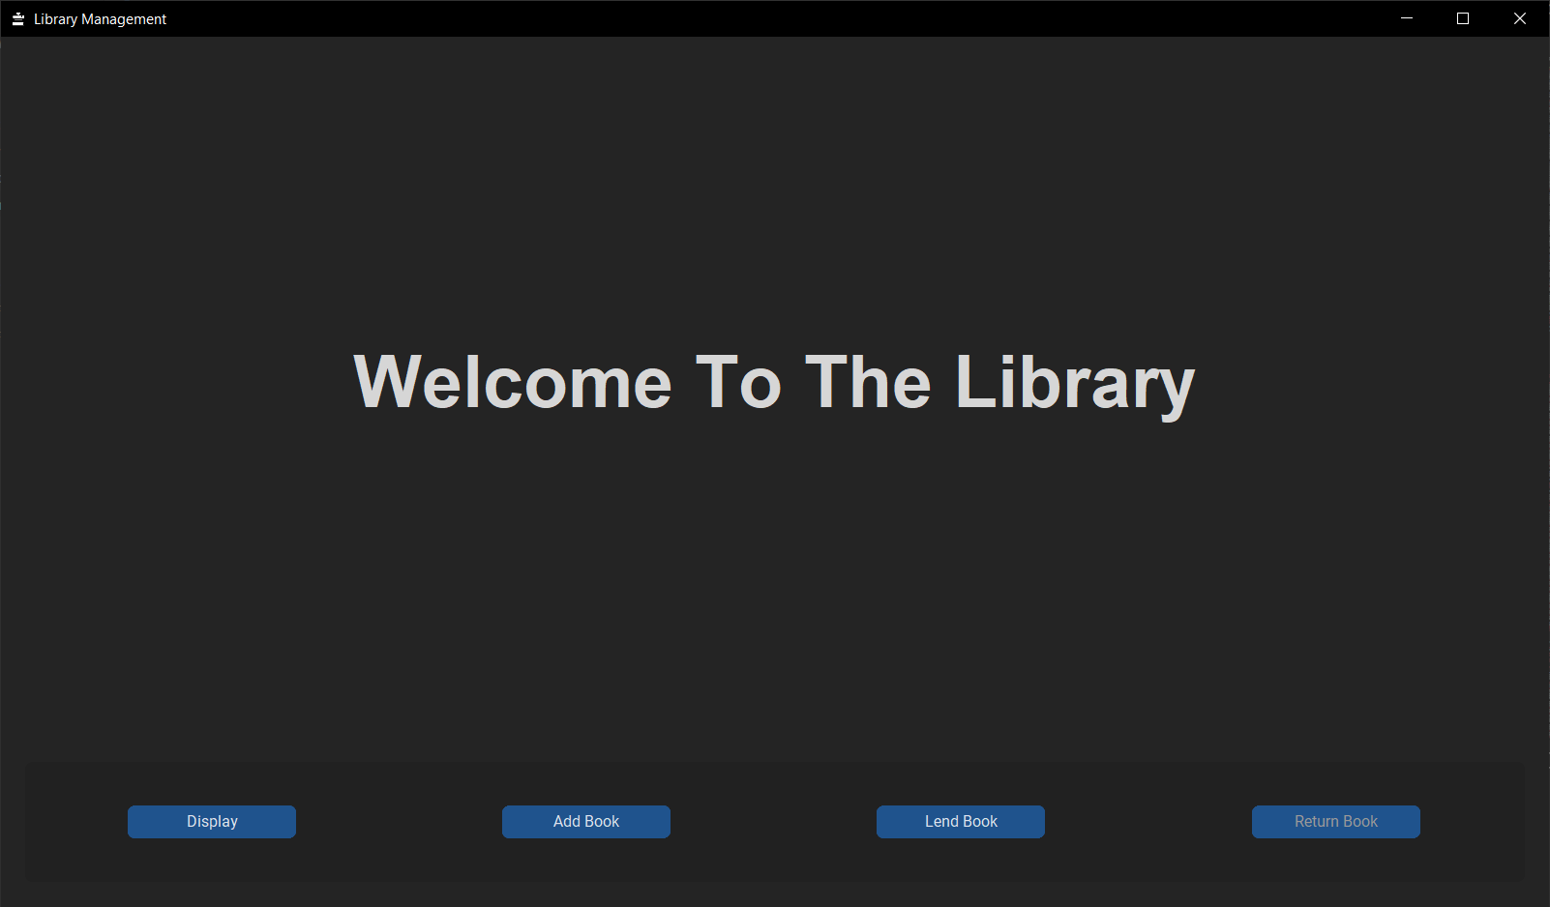

Figure

Here Are **4 Buttons** For Different Purpose According to Needs of The User.

The Display Button Shows: -

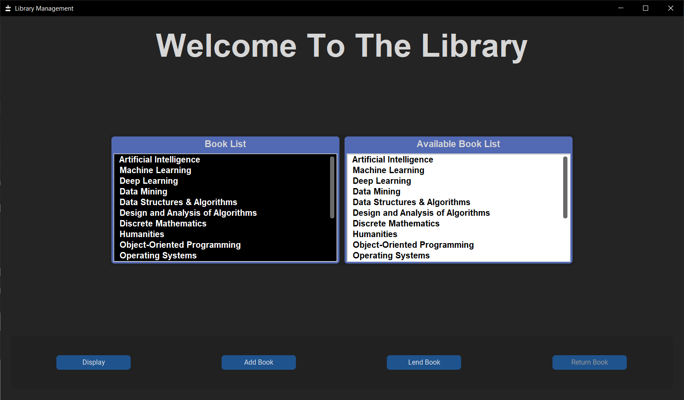

Figure

Here is List of All The **Books** And List of **Available Books**.

Now, The **Add Book Button** Shows: -

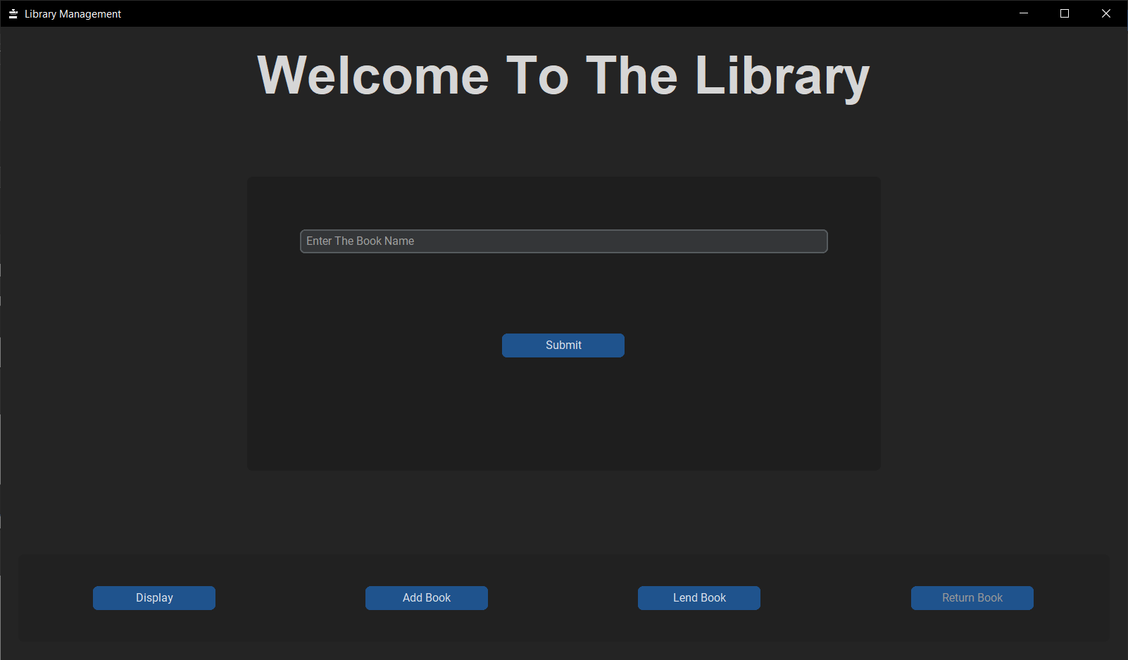

Figure

Here User Can Add Book In The Library (or Can Say Donate The Book) By **Entering The Book Name** And Click On **Submit Button**.

Now, The **Lend Book Button** Shows The Page: -

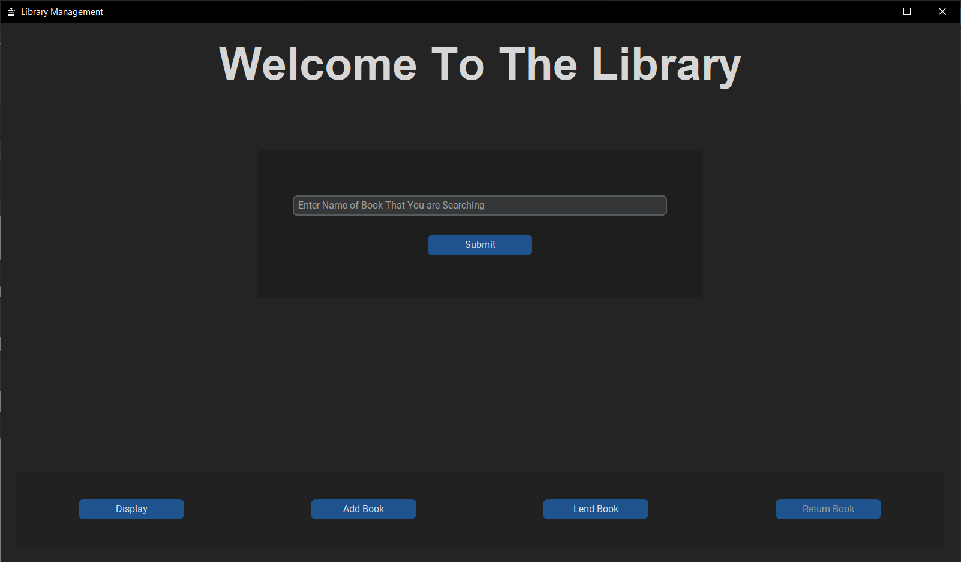

Figure

User Have To **Enter The Book Name** From The Available Books (Which User Can See From Display Tab).

If User Entered The Book Name Which is Not Present in Library, Then This Message in Red Colour Will Show: -

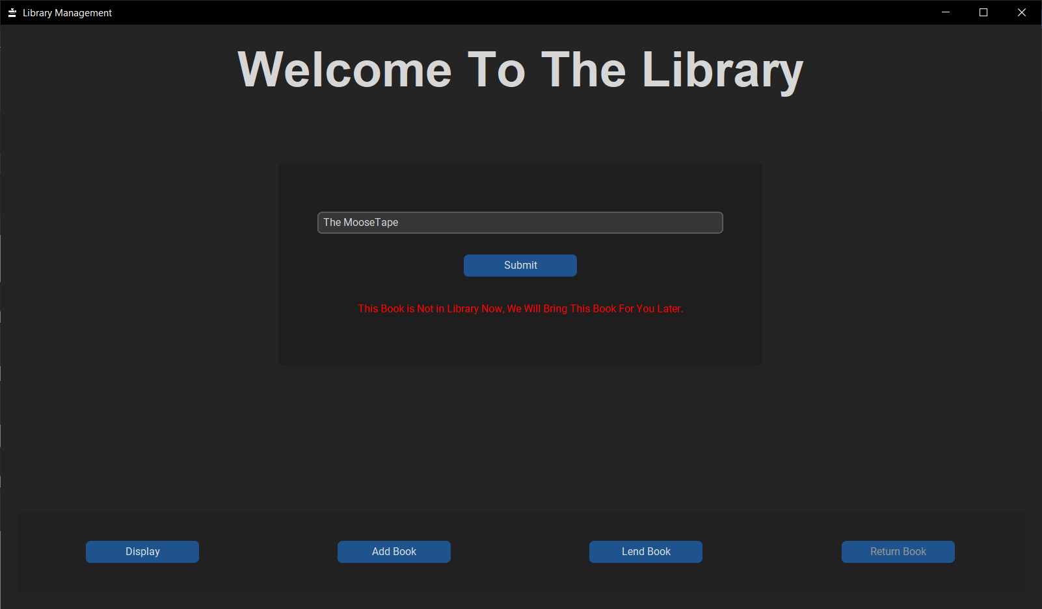

Figure

If User Entered The Book Name Which is Present in Available Book List, Then User Have To Enter His/Her Name To Lend That Book As Shown here: -

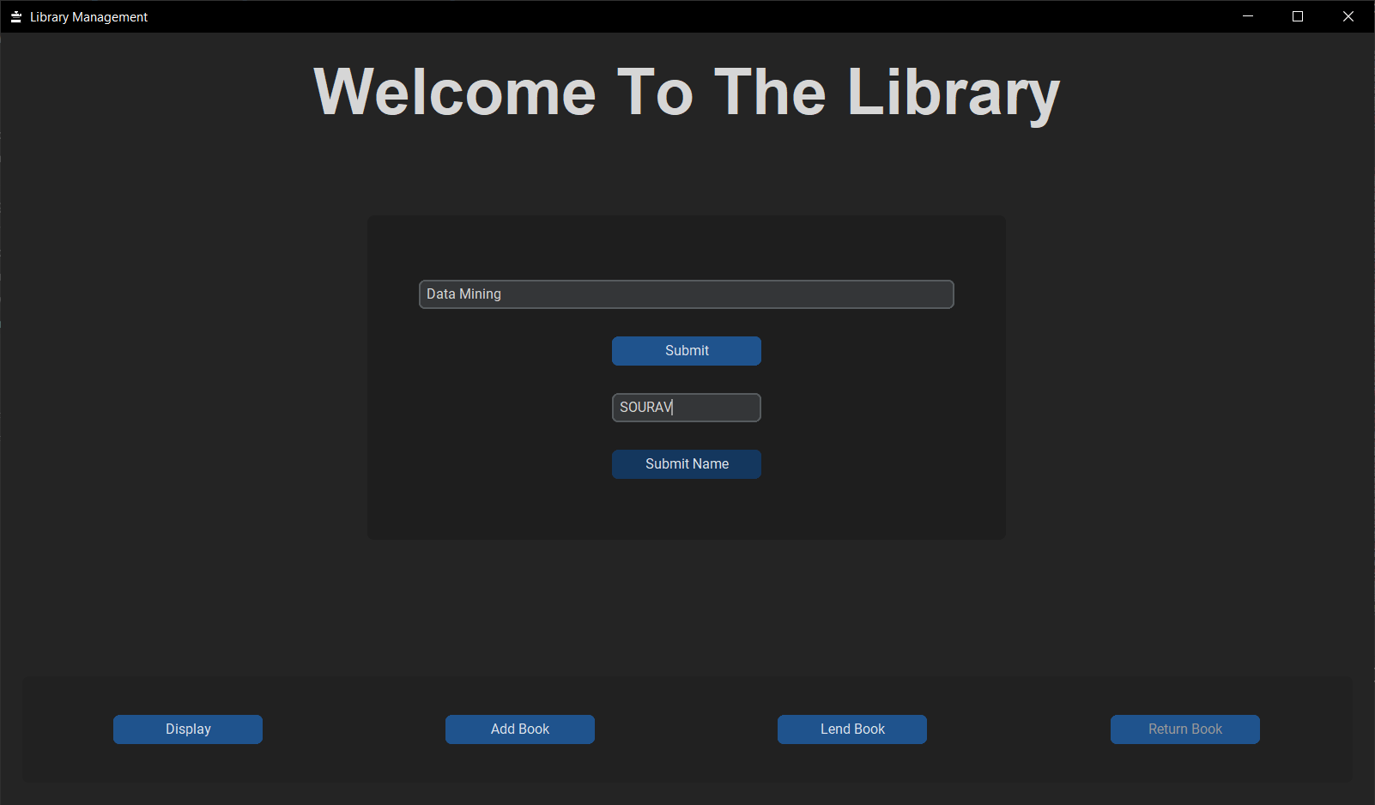

Figure

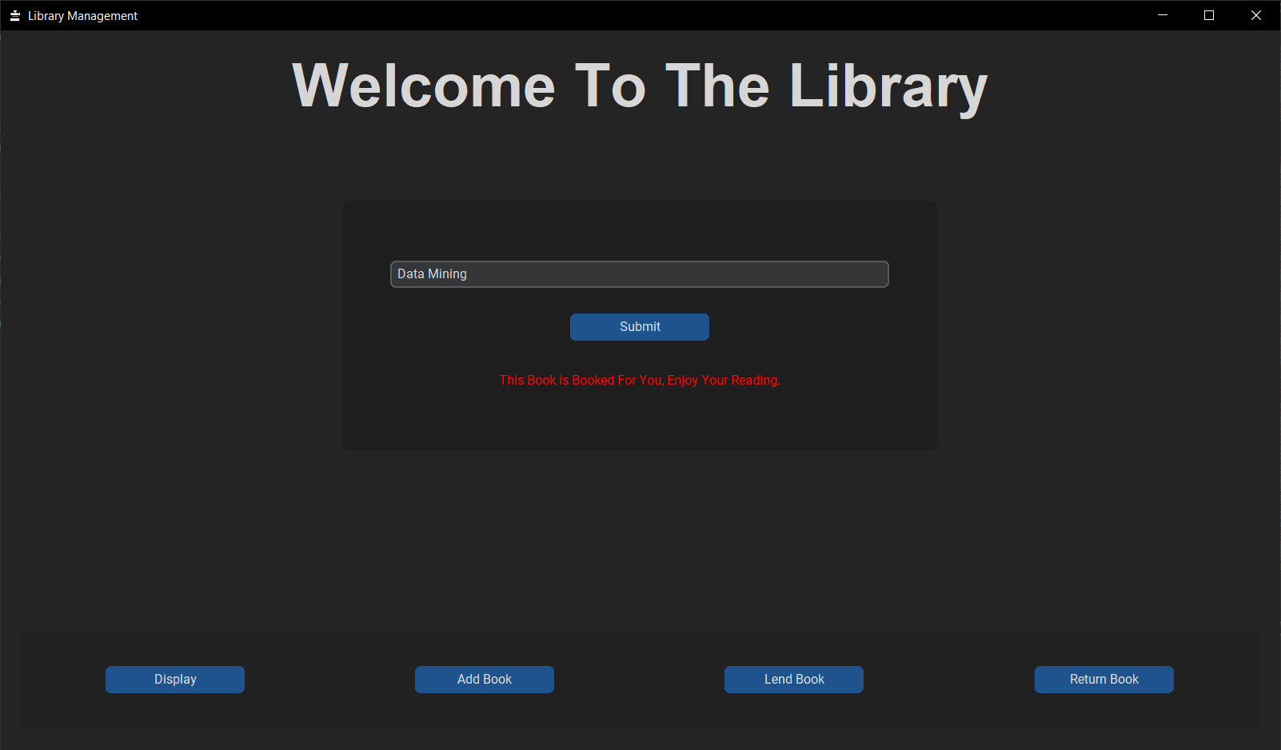

Figure

If User Entered Book Name Which is Already Lended By Another User, Then This Message Will Show: -

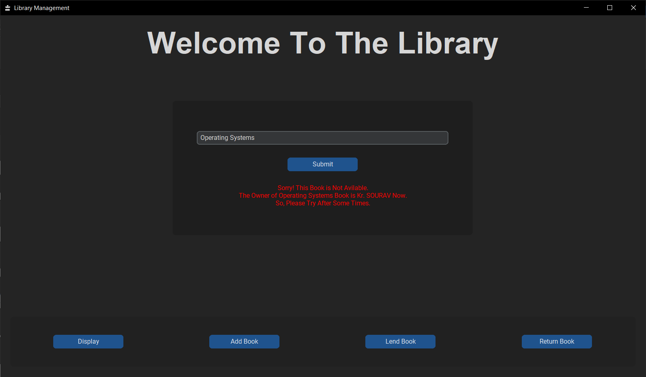

Figure

This is All About **Lend Book** Tab(Buton).

**If 1 Or More Than 1 Book is Lended, Then Return Book Button is Activated, Otherwise Disabled.**

The **Return Book** **Button** Shows The Page: -

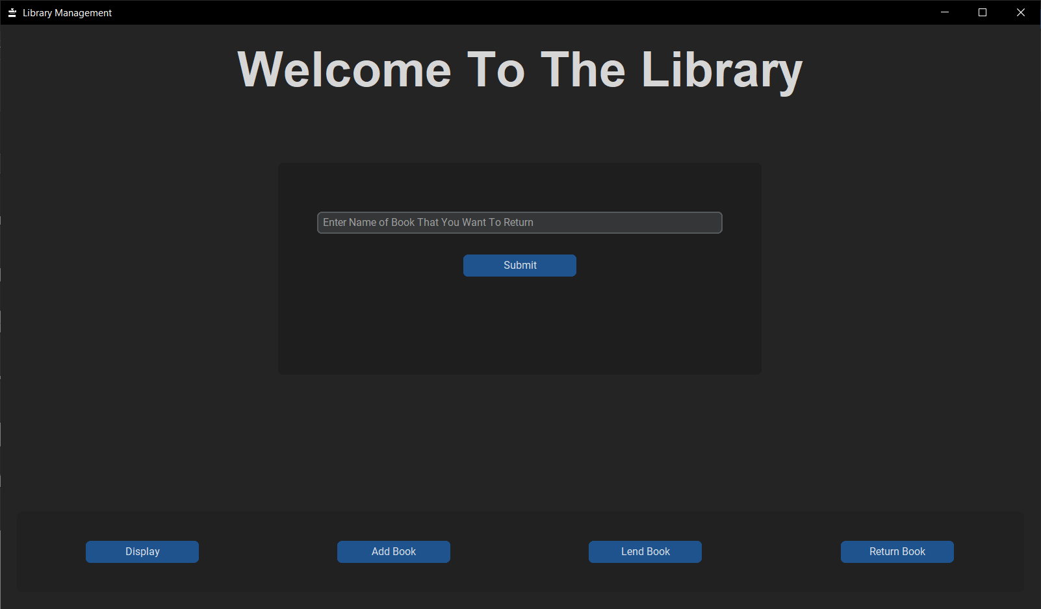

Figure

Here, User Have To **Enter The Book Name** To Return.

If User Entered The Book Name That is Not Lended Yet, Then This Message Will Shown: -

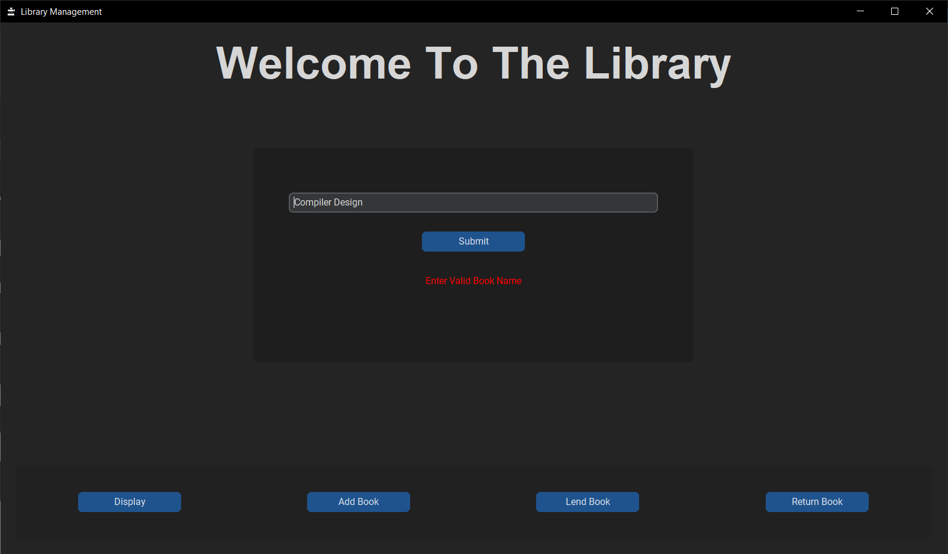

Figure

If User Entered Book Name Which is Present in Lended Book List, The Book **Will Returned Successfully** As Shown Here: -

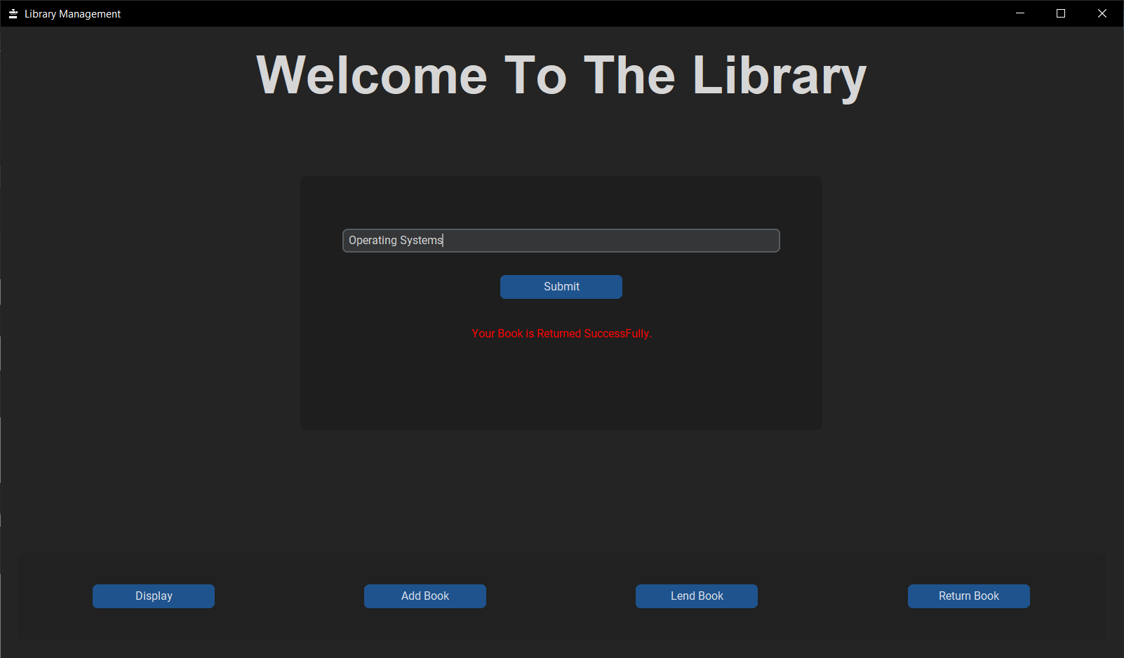

Figure

**CHAPTER 4 :** **CONCLUSION**

After Completing Training, I Was Able To Build A Prototype Of Library Management Software In Just Three Days. This Is An Exciting Project That Will Allow Me To Further Refine My Programming Skills While Creating An Incredible Future Product That Could Help Librarians Everywhere.

The industrial training that I want through within the few days brought in new technology and expanded my knowledge in the IT industry. I got the opportunity to put known concepts into practice in real project and to learn new concepts through applying them. Meeting with deadlines, keeping the code quality, trying various approaches to determine the best method and finally completing the industrial training with success were experience that gained throughout the training period. I know best. Also, even if you think your good in something there is always something new

that you haven’t learnt.

 PYHTON developer think about your future in python development. PYTHON is great tool for general purpose programming. It is user friendly one can easily understand the programming techniques.

**REFERENCE**

**Online sources**

• geeksforgeeks.org

• Code With Harry (You tube)

• Apna college (You tube)

• 3rd Party Library CustomTkinter (<https://github.com/TomSchimansky/CustomTkinter>)